
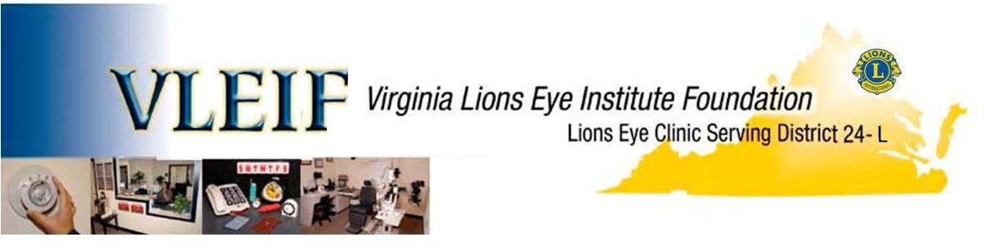VLEIF, Inc. c/o Sandra Armendaris, 7623 Virginia Ave, Falls Church, VA 22043
November 8, 2023

REPORT FROM VLEIF
VLEIF - Facebook
This will be a brief update on the activities of the VLEIF for the current year.

1. Scholastic Grants – We received 23 Scholastic Grant Applications, and the Grant Wrap-up report is attached. None of this would be possible without the Clubs. Thanks to the sponsoring clubs for your participation.

2. Eye Care for the needy expanded to Fredericksburg, VA - The Eye Care Lane donated to the Moss Free Clinic by VLEIF is about to become staffed by an eyecare professional in the very near future. Details are being worked out. Good news for the Fredericksburg area.

3. The VLEIF board approved and established the “Lion Richard A. Falls Research Grant” program with an annual budget of $40,000.00. In 2022-2023 we approved and funded Research Grants in the amount of $8,100.

4. VLEIF continues to fund and support the Lions Eye Clinic at the Inova complex. We contribute $25,000.00 per year to the operating expenses. This clinic is dedicated to providing eyecare to indigents who have no insurance.

5. The VLEIF board approved equipment expenditure for the Lions Eye Clinic Equipment in the amount of $23,762.00.

6. VLEIF also joins with the “Prevention of Blindness Society of the Washington Metropolitan Area” in support of the Alexandria Low Vision Learning Center. This practice is dedicated to serving those who are chronically visually impaired in our community.

7. The VLEIF Board has approved funds to assist the clubs with providing needed eyecare assistance when they come up against budget shortfalls. This fund is scheduled to be increased by proceeds from the dissolution of the Sight and Hearing Van Corporation. This should be a big help to clubs trying to make sure that anyone who needs help can get it. Just contact me or our District Representative and we will help when we can.

Ed “Woody” Woodard, PDG
President VLEIF – E-mail: Woodywoodard@cox.net Cell Ph: 703-314-0889
VLEIF
Lion Sheryl Bass – District VLEIF Representative - s.l.bass@verizon.net Ph: 703-361-4980

