Eyecare for the needy expanded in the Fredericksburg, VA area
It was a red letter (or at least a red ribbon) day in Virginia Lions District 24-L. The Virginia Lions Eye Institute Foundation (VLEIF) which is in District 24-L, went to great lengths to establish an eyecare facility in Fredericksburg, VA, one of the underserved areas within the district. VLEIF Expansion Task Force leader PCC Wilma Murphy spearheaded this effort with the blessings of DG Rose Burrus and enthusiastic cooperation from the Moss Free Clinic.
The Virginia Lions Eye Institute Foundation (VLEIF) was incorporated in 1979 with the goal of providing a scholarship grant program to sight handicapped individuals. The Foundation is currently providing scholarships up to $3,000 each for approximately 20 sight impaired students annually.
In 1966, prior to the Foundation being incorporated, the Lions Eye Clinic provided basic eye care to people who could not afford eye care. In 1974 the Clinic moved to Fairfax Hospital and uses state-of-the-art equipment.
In 2021 VLEIF made a plan expand and begin a clinic in another part of the District. The VLEIF Expansion Task Force contacted the Moss Free Clinic in Fredericksburg, VA. VLEIF proposed to provide the required equipment to have an eye clinic as part of the Moss Free Clinic. Even though COVID Restrictions made it difficult, it was still a successful venture.
The Expansion Task Force held its open house at the Moss Free Clinic on Wednesday, September 14, 2022. Mary Katherine Greenlaw, Mayor of Fredericksburg, performed the ribbon cutting. A number of physicians attended the ribbon cutting ceremony and expressed an interest in donating time to perform eye exams on patients of the clinic.
PCC Wilma
Chair, Expansion Task Force

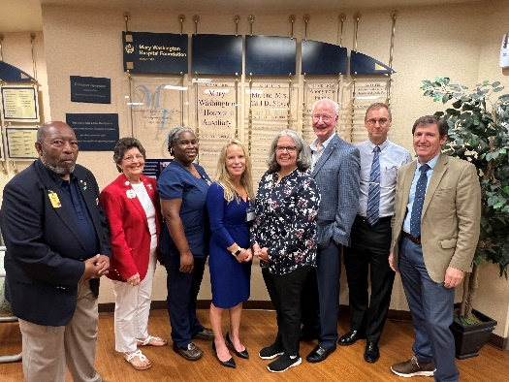

L-R PDG Ed “Woody” Woodard (President VLEIF); PCC Wilma Murphy (Task Force Leader); Joanne Henry, RN (Clinic Dir); Corie Bacher (Clinic Mktng Mgr); DG Rose Burrus; Lion Ken Lapin (Task Force member); Dr Mark Falls (VLEIF Board Member); Dr. Wade Fiegl, OD (Local Optometrist).

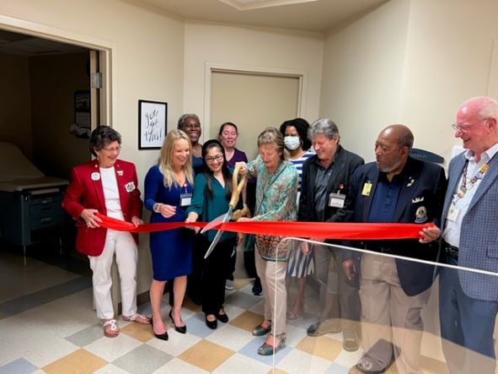

Mayor Mary Katherine Greenlaw performing the ribbon cutting.
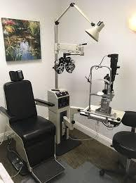

Equipment ready for business.

